**Mrs. M.SHARMILA,**

**Assistant Professor**

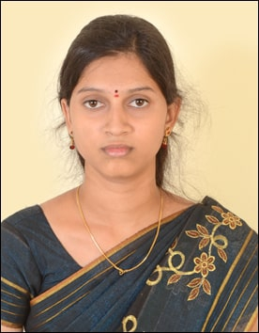

# Education Qualification:

* B. E.– Electrical and Electronics Engineering – P.R.Engineering College, Thanjavur.
* M.Tech. – Power Systems – PRIST University, Thanjavur.

# Experience:

Worked as Assistant Professor in Department of EEE at A.R.J Group of Institutions, Mannargudi from June 2017 to June 2019.

**Area of Specialization:**

* Power system.
* Electrical circuit theory
* Power Quality
* Electronic Devices and Circuits
* Industrial Electronics

# Paper Publications:

1. Published a paper in an International Journal (IJERT) - Entitle of “Compensation of Power quality Issues using Fuel Cell with Electrolyzer/Pv/Wind Turbine” vol.40., no 7, October 2016.
2. Published a paper in International Journal of Research in Science & Engineering (IJRSE) –“Power Quality disturbance classification using data mining techniques”, vol.3, Issue.3, May 2017.

**Conference Participated:**

1. Participated on National conference (NCPRS’17) -“Power Quality disturbance classification using data mining techniques” in PRIST University on May 2017.

**Workshop Attended:**

1. “Industrial Automation” held at P.R.Engineering College
2. “Energy Systems” held at SASTRA University
3. “Image processing” held at NIT,Trichy.
4. “Renewable energy sources” at PRIST University.